# SQL TEST1 Spring 2020.

Submit via UTS online or Canvas. Take a screenshot of your answers and SQL code and paste it in a word document and upload it like an assignment upload. All questions carry equal marks.

**Submit by 8 PM 11 Sep 2020.**

## Produce the given result using SQL syntax.

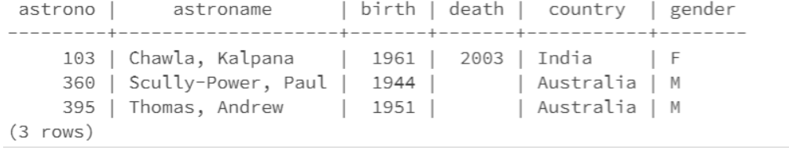

select * from NASA2_astronaut where country = 'India' or country = 'Australia'; 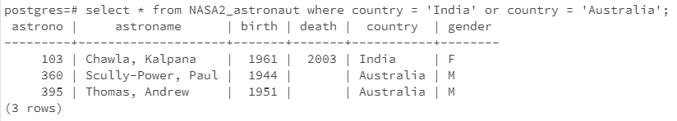

## Produce the below result using a natural join.

Hint : missionno is not an integer data type.

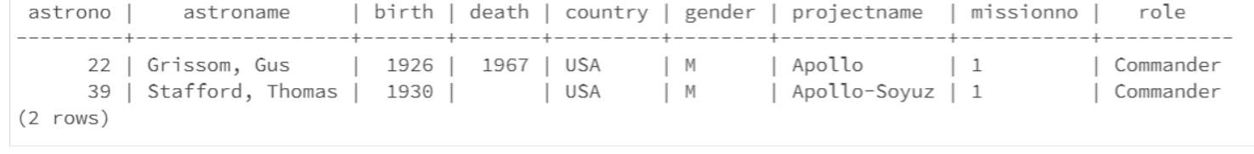

Select * from NASA2_Astronaut natural join NASA2_Assigned where missionno = '1' and role = 'Commander';

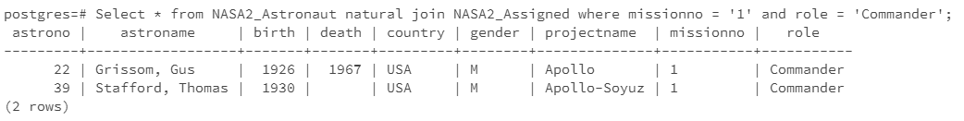

## Produce the below result using cross product.

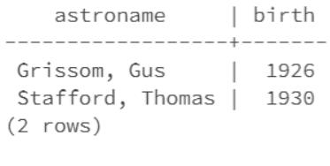

select astroname, birth from NASA2_astronaut, NASA2_assigned where NASA2_astronaut.astrono = NASA2_assigned.astrono and missionno = '1' and role = 'Commander';

